**Theory and Background: -**

The food retail industry is a highly competitive sector where customer preferences and sales dynamics are influenced by various factors, including time, location, and product offerings. In this context, data-driven decision-making is essential for businesses to thrive and maintain an edge over competitors.

**Grilled Galaxy Burgers**, a burger retail chain in Italy, serves as a prime example of a business that relies on data analytics to optimize its operations and enhance customer experience. Established with the goal of providing high-quality burgers and an exceptional dining experience, the chain has grown rapidly, with multiple outlets spread across Italy. However, as the chain expanded, so did the complexity of managing its operations and sales performance across various locations.

Recognizing the potential of data analytics, **Grilled Galaxy Burgers** embarked on a journey to harness the power of their sales and operational data. This project centers on leveraging **MySQL** for data cleaning and exploratory data analysis (EDA) and **Power BI** for creating interactive dashboards to visualize key business insights.

**Importance of Data Analytics in Retail**

In a retail chain like **Grilled Galaxy Burgers**, data analytics plays a crucial role in:

* **Understanding customer behavior**: Identifying patterns in purchasing habits, such as peak sales hours and the most popular products.
* **Optimizing operations**: Monitoring sales performance across locations to identify underperforming stores or menu items.
* **Enhancing profitability**: Analyzing sales trends to forecast demand and improve inventory management.
* **Strategic decision-making**: Leveraging insights from data to make informed decisions regarding marketing campaigns, promotions, and resource allocation.

**Scope of the Project**

The project involves analyzing the sales data of **Grilled Galaxy Burgers** to uncover actionable insights that can drive business success. By focusing on key metrics such as sales by time of day, weekday vs. weekend performance, and top-performing locations and products, the analysis aims to provide a comprehensive overview of the chain’s performance.

**Technologies Used**

1. **MySQL**: Used for data cleaning and exploratory data analysis. The structured query capabilities of MySQL ensure efficient handling of raw data, enabling transformation into meaningful datasets ready for visualization.
2. **Power BI**: A versatile business intelligence tool used to create interactive dashboards. Power BI helps translate complex datasets into clear and actionable visualizations, offering stakeholders an intuitive way to understand the results.

**Key Areas of Analysis**

The analysis covers the following critical aspects of the business:

* **Sales by Time of Day**: Identifying peak sales hours to optimize staffing and inventory.
* **Sales Trends Over Time**: Monitoring monthly and daily sales trends to evaluate performance and detect seasonal patterns.
* **Top Store Locations**: Highlighting the most successful stores based on total sales, allowing targeted strategies for underperforming locations.
* **Top Products**: Understanding which items are driving revenue and which may require promotional efforts.
* **Sales by Weekday vs. Weekend**: Exploring how customer traffic changes based on the day of the week.
* **Peak Sales Times**: Analyzing specific days and times that generate the highest revenue, helping refine marketing campaigns and promotions.

**Significance of the Study**

This project demonstrates the importance of integrating data analytics into business processes. The insights generated can guide **Grilled Galaxy Burgers** in refining its operations, enhancing customer satisfaction, and maximizing profitability. The approach used in this project is scalable and can be adopted by other retail businesses aiming to leverage data for growth.

By combining the analytical capabilities of MySQL and the visual storytelling power of Power BI, this project not only showcases the potential of data analytics in retail but also serves as a practical example of how businesses can turn raw data into actionable insights.

**Problem Statement: -**

1. **Overall Sales Analysis:**

Calculate Overall Sales, total no. of orders & quantity sold for each month.

Calculate increase or decrease in sales, no of orders placed & quantity sold, for month-to-month basis.

Find difference over previous month for sales, order placed and quantity sold.

1. **Data Visualization Requirement:**
2. Calendar Heat Map:

* Implement a calendar heat map that dynamically adjusts based on the selected month from a slicer.
* Each day on the calendar will be color-coded to represent sales volume, with darker shades indicating higher

sales.

* Implement tooltips to display detailed metrics (Sales, Orders, Quantity) when hovering over a specific day.

1. Sales Analysis by Weekdays and Weekends:

* Segment sales data into weekdays and weekends to analyze performance variations.
* Provide insights into whether sales patterns differ significantly between weekdays and weekends.

1. Sales Analysis by Store Location:

* Visualize sales data by different store locations.
* Include month-over-month (MoM) difference metrics based on the selected month in the slicer.
* Highlight MoM sales increase or decrease for each store location to identify trends.

1. Daily Sales Analysis with Average Line:

* Display daily sales for the selected month with a line chart.
* Incorporate an average line on the chart to represent the average daily sales.
* Highlight bars exceeding or falling below the average sales to identify exceptional sales days.

1. Sales Analysis by Product Category:

* Analyze sales performance across different product categories.
* Provide insights into which product categories contribute the most to overall sales.

1. Top 10 Products by Sales:

* Identify and display the top 10 products based on sales volume.
* Allow users to quickly visualize the best-performing products in terms of sales.

1. Sales Analysis by Days and Hours:

* Utilize a heat map to visualize sales patterns by days and hours.
* Implement tooltips to display detailed metrics (Sales, Orders, Quantity) when hovering over a specific day-hour.

**Analysis and Findings: -**

We had received data in an excel first. In order to create a database in MySQL and import the data we will need the data in csv format. So we have converted data from excel file to csv file.

After importing the table into MySQL database, we will perform data cleaning and transformation.

In MySQL, having spaces in table names can cause issues because spaces need to be escaped using backticks (`) whenever we reference the table. It's generally best to rename the table to remove spaces. Since the table we imported has spaces we will use RENAME TABLE statement to change table name which has underscores instead of spaces.

RENAME TABLE `grill galaxy burger sales` TO grill_galaxy_burger_sales;

Now we will use DESCRIBE statement to see data type of all the columns

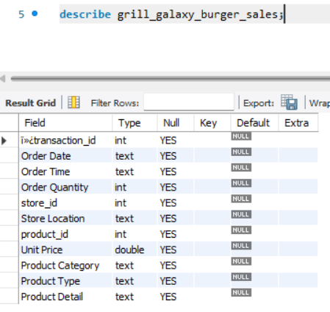

We see 3 issues here the data type of the column Order Date and Order Time is text which is wrong and needs to be changed and the column heading for transaction_id has some random symbols at the beginning and many columns have spaces in their name and needs to be replaced with an underscore.

Now we will use ALTER statement to change column names making sure that there are no spaces in them and also change the data type of order_date and order_time column.

Following code was used to change data type of columns: -

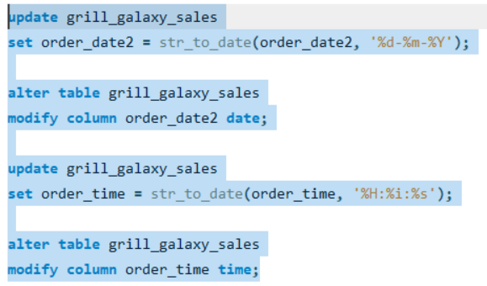

Following codes were used to rename columns: -

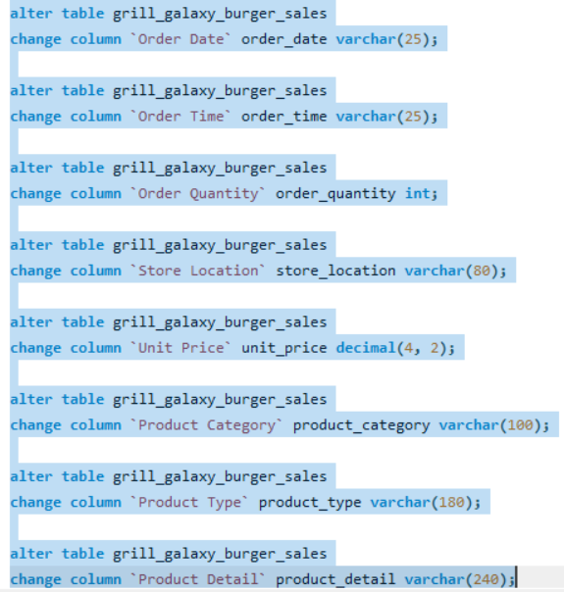

Now we will correct the transaction_id column name and remove unnecessary symbols from the front.

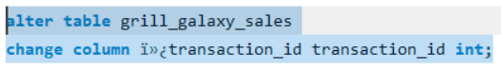

After performing these 3 changes for cleaning the data we check to see if the columns have changed.

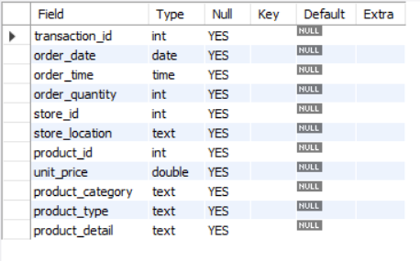

Now that we have done data cleaning, we will move on to find answers to business questions.

Q1 Find total sales for each respective month

Ans.

For calculating total sales amount we do not have a sales amount column, so we will create it by multiplying order_quantity by unit_price

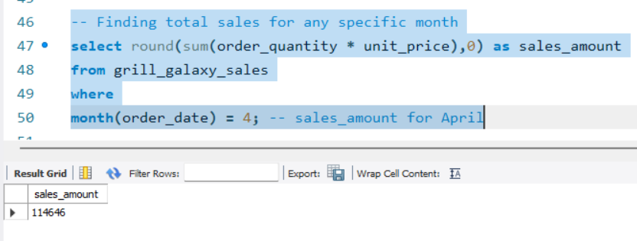

Q2 Find Increase or decrease in sales on month to month basis

Ans.

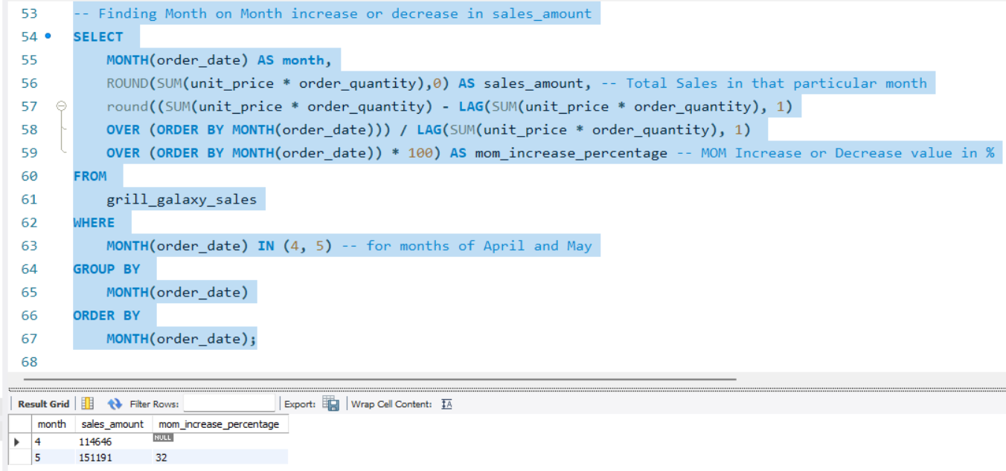

Q3 Finding total number of orders for any specific month

Ans.

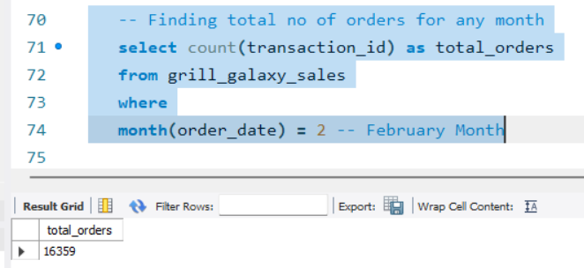

Q4. Finding month on month increase or decrease in orders placed

Ans.

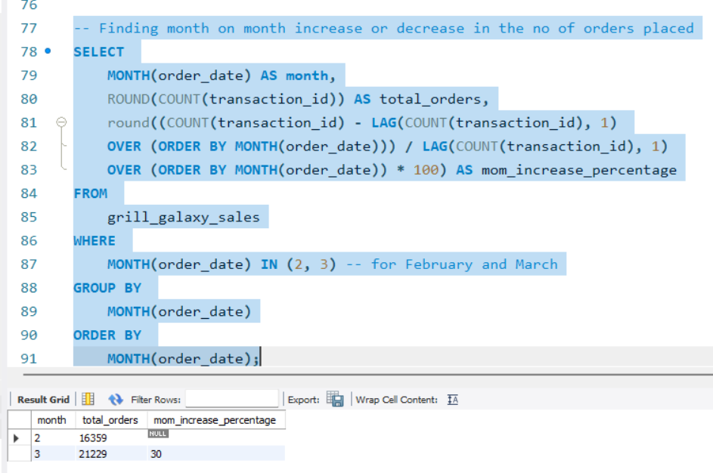

Q5. Find total quantity of food items sold for a particular month

Ans.

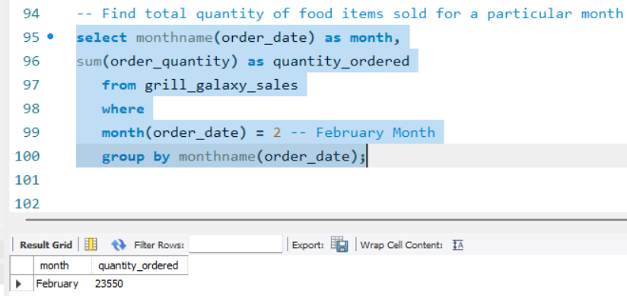

Q6. Find month on month difference in quantity of food items sold.

Ans.

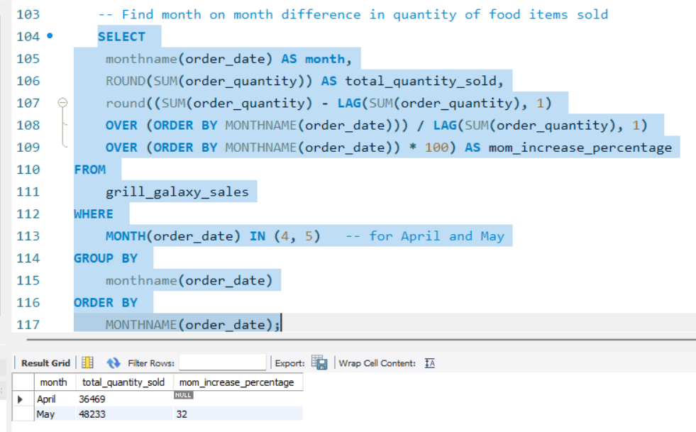

Q7. Create a date based query which shows sales, orders & quantity based on month and day selected.

Ans.

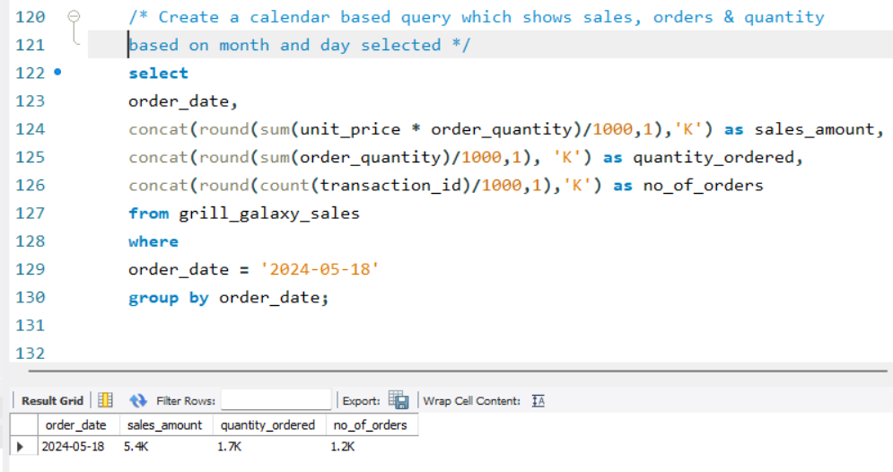

Q8. Write a query to show sales metrics by weekdays and weekends.

Ans.

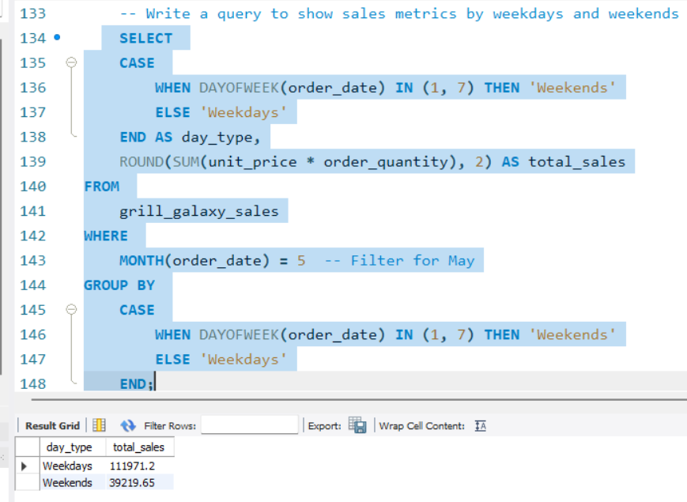

Q9. Find sales metrics by different store locations.

Ans.

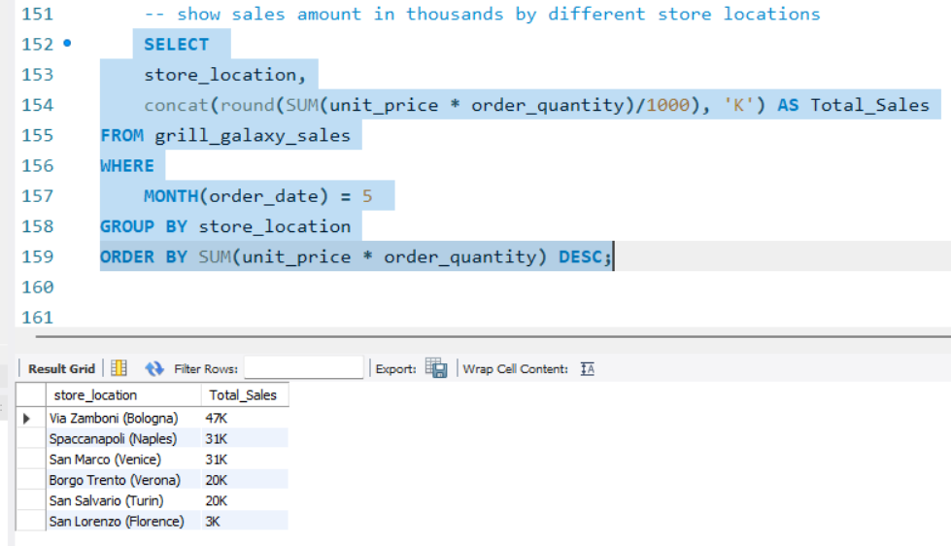

Q10. Write a query to find out if the sales on a given day is above average or below average.

Ans.

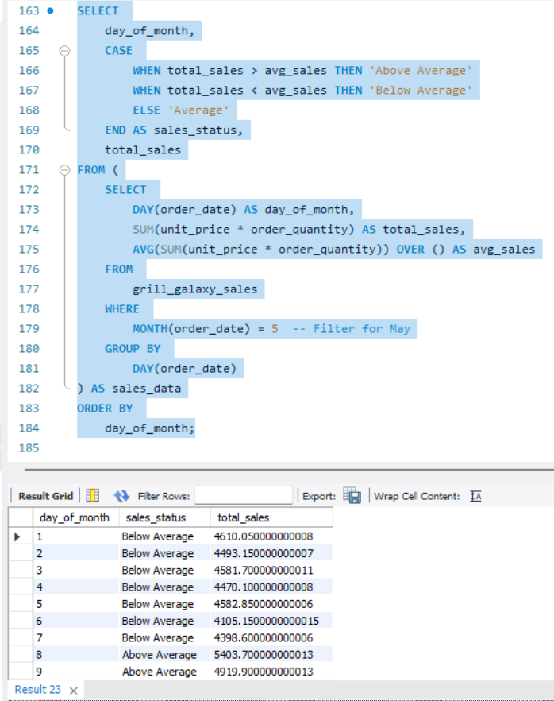

Q11. Find total sales amount by product categories.

Ans.

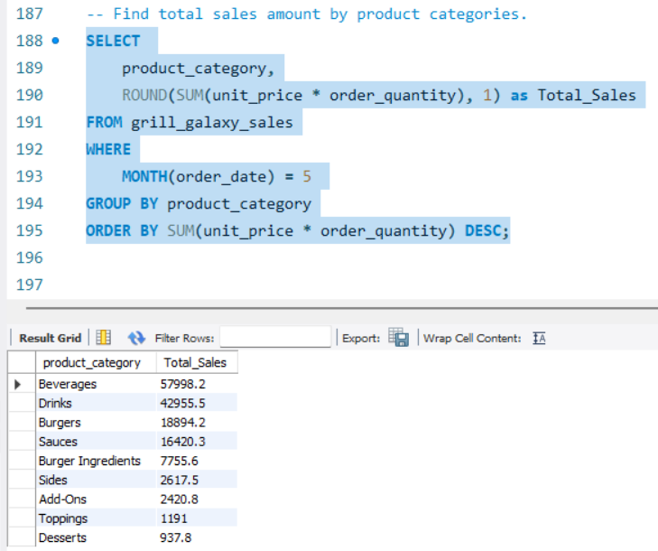

Q12. Find Top 10 food items by their sales amount.  
Ans.

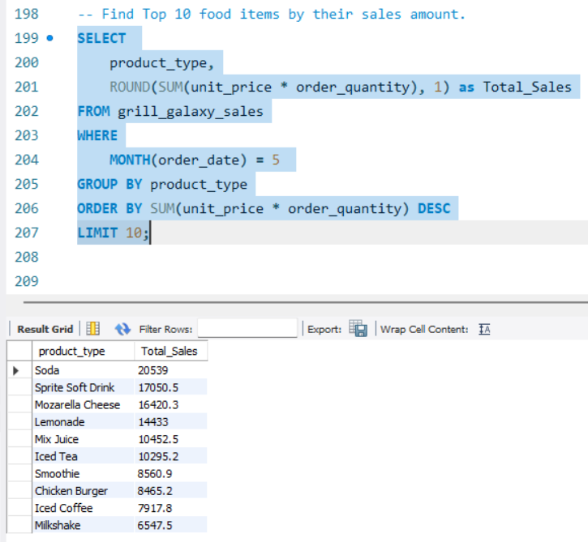

Q13. Write a query to return sales amount for a specific day and hour.  
Ans.

